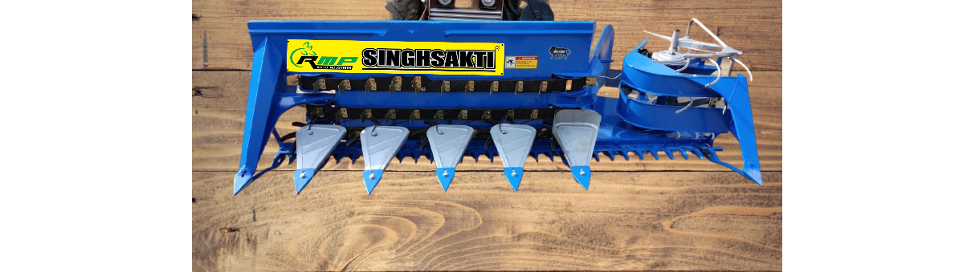 **REAPER BINDER**

* Reaper is very useful in **cutting standing crpos** like**wheat, Maize(Mecca), Soyabean, Jowar, Bajra, Chana**   etc. 3-4 inches above the ground level. The Cut crop is carried to its extreme right with the help of conveyor belt & is placed in a line.
* It saves time, Labour and Money.
* Available in different sizes according to demand and ranges from 14 H.P to 50 H.P Tractors
* It can be easily mounted on Tractors.
* “Maintenance Free”